


TeeChart example.

This TeeChart is inserted into the page as an object from the object list. It remains live on the page and may be zoomed/scrolled or acted upon by code.

* Important – If security is set to ‘high’ in your Word installation the script will not run. Please set security to medium or low to see this demo.

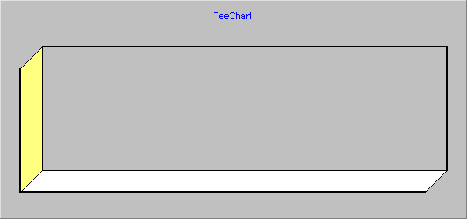
Drag with mouse on Chart to rotate

